First Controller:

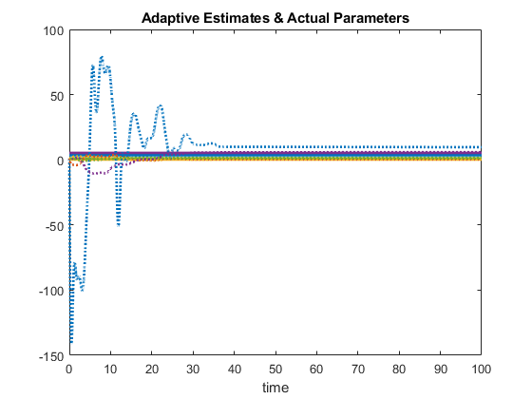









Here we see that controllers are bounded, errors converge as well as parameters, however, there is some steady state error for one of them. While tuning gains, we either got underdamped parameters that don’t converge fast enough or the one that converges with some steady state error, I chose the one with steady state error.

Second Controller:







Here we observe a higher number of oscillations and poorer steady state error.

Controllers are bounded and errors converge to zero.

Third controller:



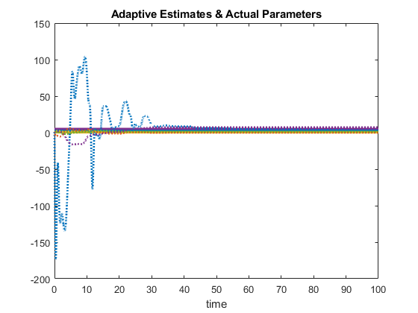



In this controller we see that the steady state error of the parameters have been reduced, while errors converge at the same rate and controllers remains bounded.

Fourth Controller:



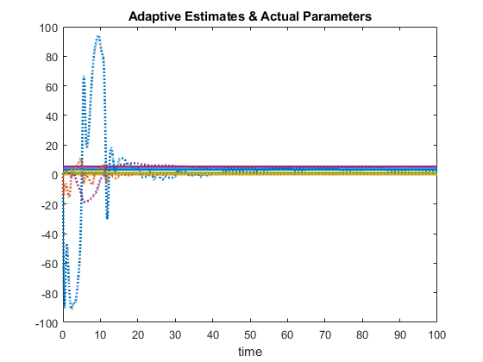



Here we see the oscillations are lesser than the former ones.

However the performance of all four adaptations are similar.